**Experiment No. 05**

* 1. **Experiment Name**

DC-DC boost converter using pi controller and Single-phase H bridge DC-AC inverter using Simulink

* 1. **Objectives**
* To become acquainted with the Simulink platform and Simulink library
* To design and analyze DC-DC converter using pi controller
* To design and analyze Single-phase H bridge DC-AC inverter using Simulink platform
  1. **Theory**
     1. **DC-DC boost converter**

A direct current (DC) to direct current (DC) converter is an electrical circuit or electromechanical device that converts a direct current (DC) source from one voltage level to another. It is a form of energy converter. Power levels range from extremely low (tiny batteries) to extremely high (high-voltage power transmission).

* + 1. **Single-phase H bridge DC-AC inverter**

The inverter is a device that converts a dc voltage into ac voltage and it consists of four switches. It is also known as full-bridge inverter circuit. A full-bridge inverter's circuit consists of four diodes and four regulated switches. Because they feed the stored energy in the load back into the DC source, these diodes are known as freewheeling diodes.

* 1. **Apparatus**
* Simulink
  1. **Simulink Block Diagram & Waveform**
* **DC-DC boost converter using pi controller**
* **Code for MATLAB function**

function y = fcn(Vact,Vref)

ss=0.05;

persistent d

if isempty(d),d=0; end

if Vact<Vref

d=d+ss;

if d>0.65

d=0.65;

end

elseif Vact>Vref

d=d-ss;

if d<0

d=0;

end

else

d=d;

end

y=d;

end

* **Block diagram**

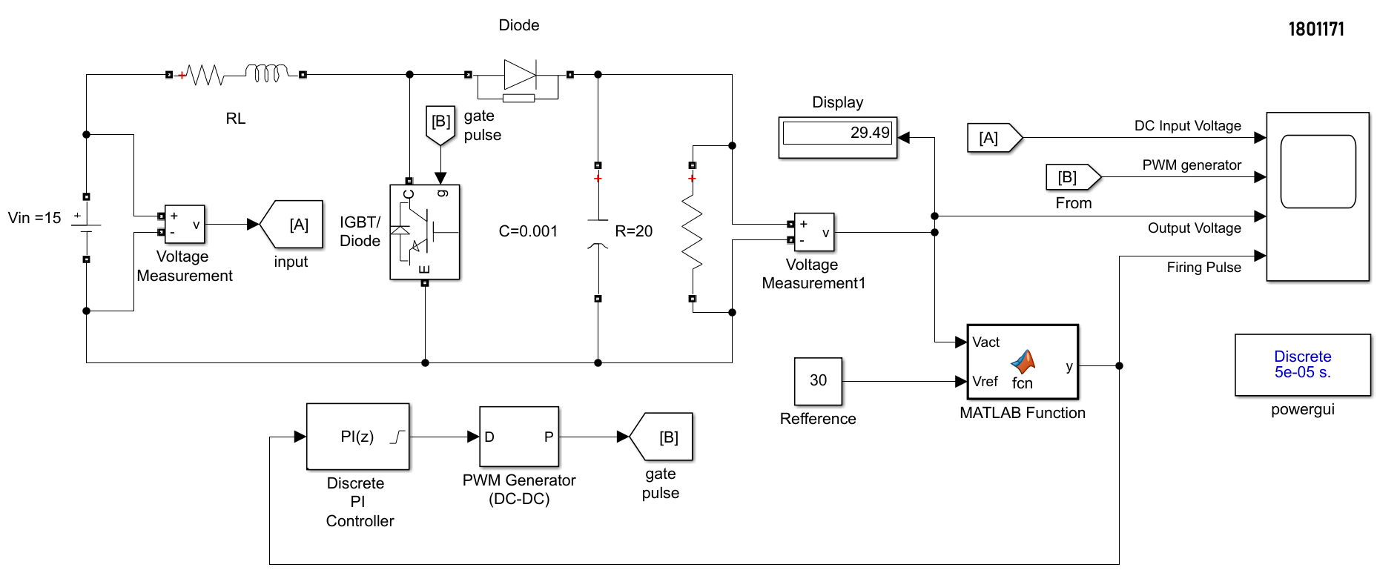Fig. 5.1: Block diagram for DC-DC boost converter using pi controller

* **Waveform**

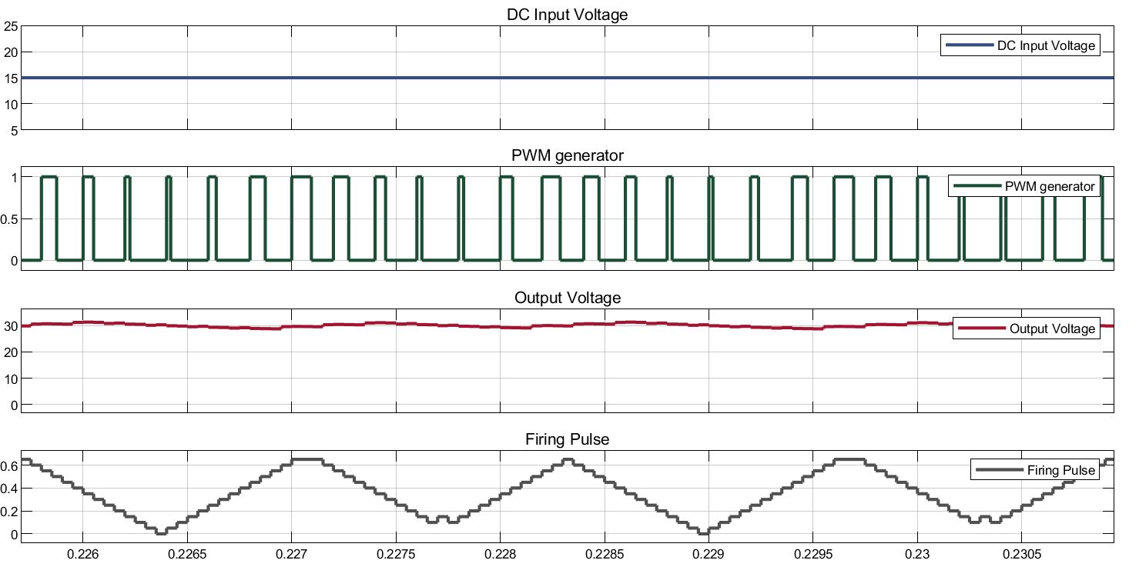

Fig. 5.2: Waveform for DC-DC boost converter using pi controller

* **Single-phase H bridge DC-AC inverter**
* **Code for MATLAB function**

function [Q1 ,Q2 ,Q3 ,Q4,Vc1,Vc2] = pulse(Vref, Vt)

Vc1 = (Vt+1)*0.5;

Vc2 = (Vt-1)*0.5;

if Vref>0

if Vref >= Vc1

Q1=1;

Q2=1;

Q3=0;

Q4=0;

else

Q1=1;

Q2=0;

Q3=0;

Q4=1;

end

elseif Vref<0

if Vref<=Vc2

Q1=0;

Q2=0;

Q3=1;

Q4=1;

else

Q1=0;

Q2=1;

Q3=1;

Q4=0;

end

else

Q1=0;

Q2=0;

Q3=0;

Q4=0;

end

end

* 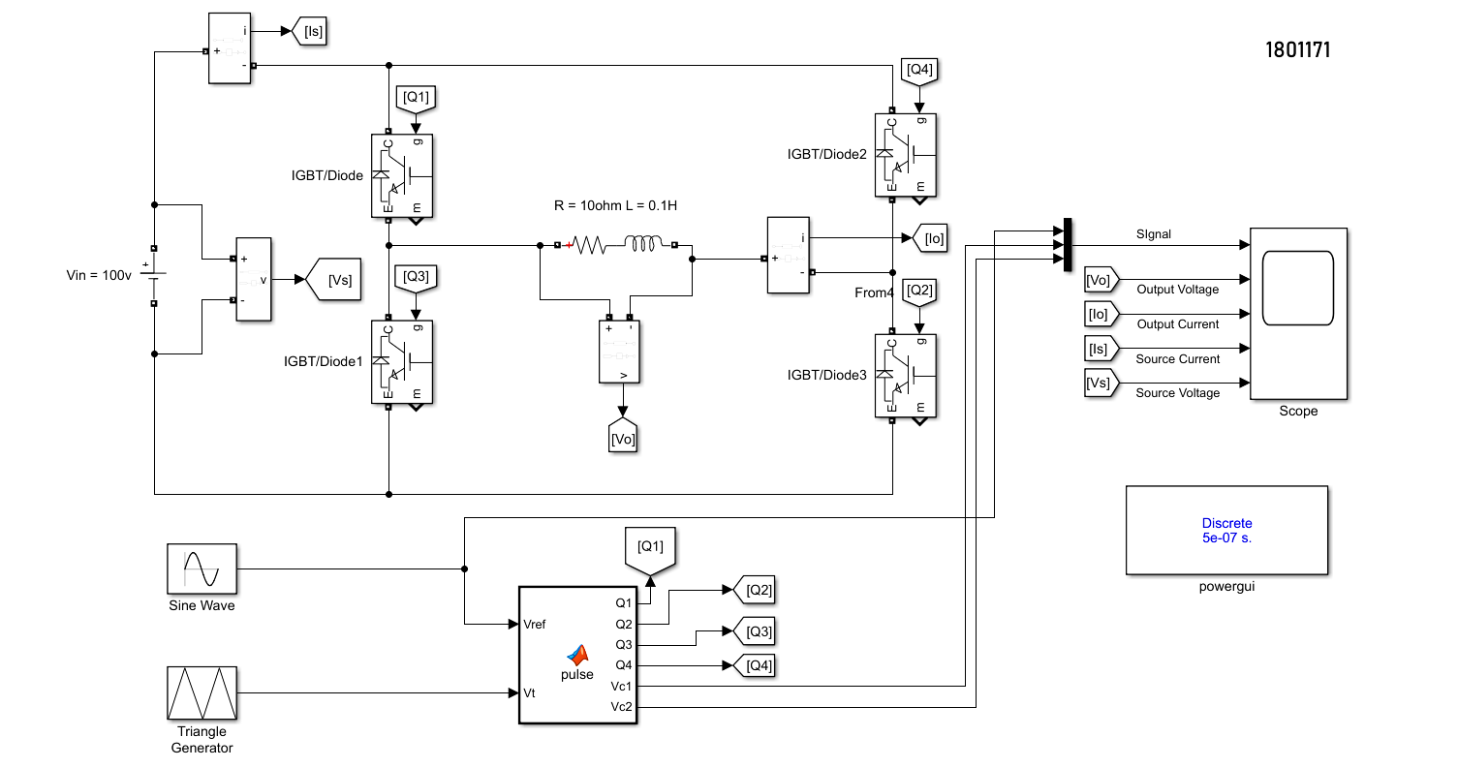**Block diagram**

Fig. 5.5: Block diagram for Single-phase H bridge DC to AC inverter

* **Waveform**

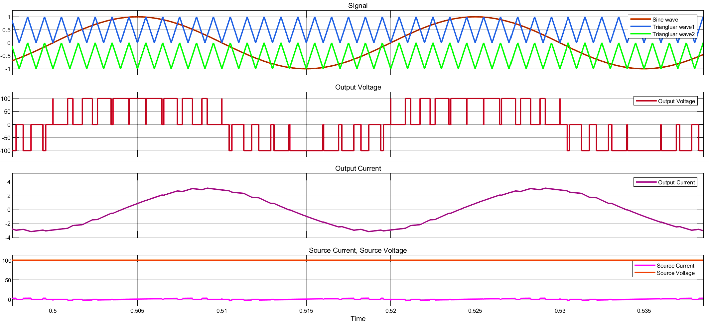

Fig. 5.4: Waveform for Single-phase H bridge DC to AC inverter

* 1. **Discussion & Conclusion**

In this experiment, we were able to successfully design a DC-DC boost converter circuit using a Pi controller and a single-phase H-bridge DC-AC inverter using Simulink. We used IGBT and MATLAB functions and analyzed their characteristics through this experiment. Moreover, we compared our theoretically obtained waveform with the simulated waveform. In the end, expected outputs were observed within scope. Thus, the experiment was a success.